CPSC 1160 – Assignment 3

**Due Date: Check D2L – No late assignments accepted**

Data Source: Employee_Data.csv

**Fields:** id, first_name, last_name, gender, department, salary

Problem Statement

Write a program that would read the given data source and provide the user with custom reports

Sorting Algorithm: use Merge Sort

Your program must meet the following requirements:

1. Create a menu with the following options
2. Display All
3. Group by Department
4. Group by Gender
5. Exit
6. Display All [2 marks]

It should display the contents of the file, sorted in ascending order by id, and with the total salary at the end of the report. Don’t forget to replace Your Name with your real name.

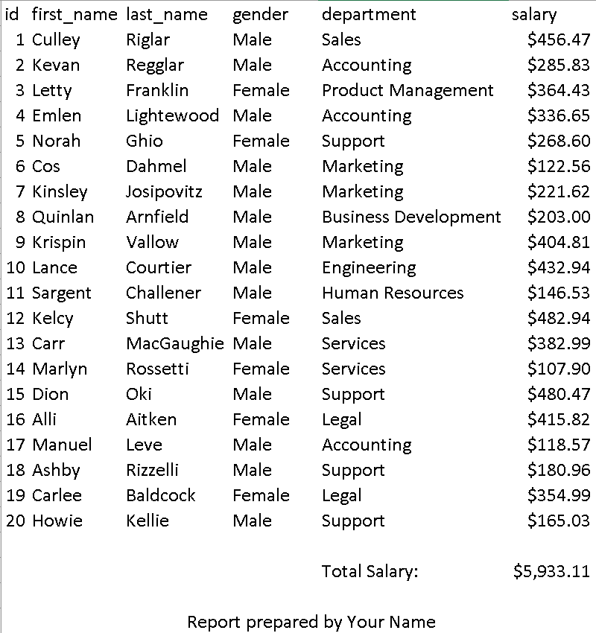

1. Group by Department [4 marks]

* Sample output below.

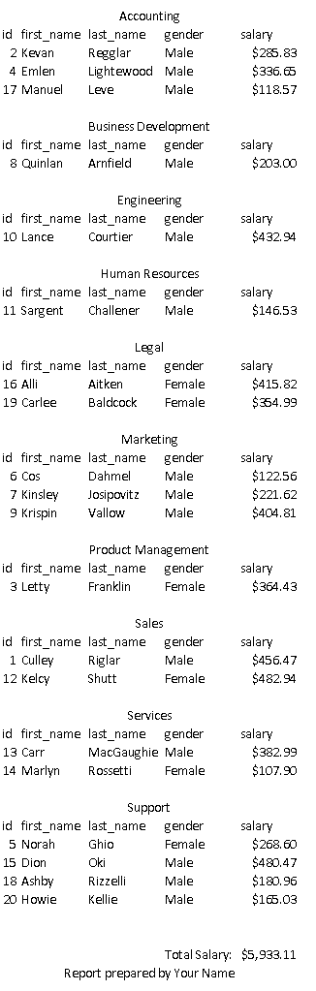

1. Group by Gender [4 marks]

* Additional requirements: sort by id in ascending order, running total, grand total, and your name

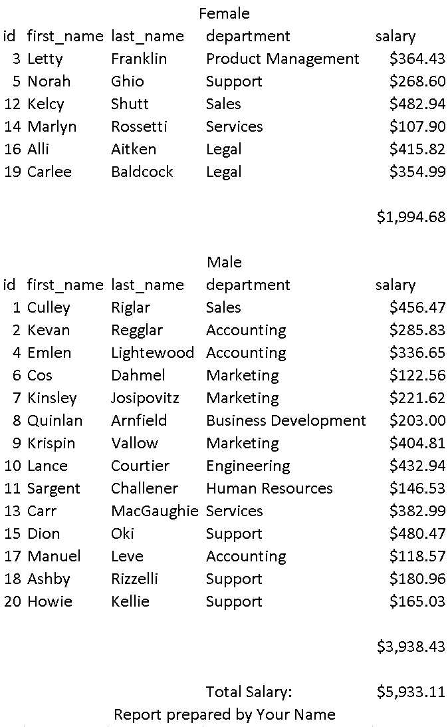

Running total

1. You need to implement the menu within a loop. It would only exit the loop when user selects 4 (Exit). If not implemented, you would get 30% deduction from the total marks.

Submissions

1. Submit your program to D2L in the Assignment3 Folder
2. Filename: AS3_yourStudentid.cpp
3. Must use function prototype whenever necessary.
4. Refrain from putting all the tasks in one function